TASK 1.1:JAVA LAMBDA EXPRESSIONS

PROGRAM:
import java.io.*;
import java.util.*;
interface PerformOperation {
boolean check(int a);
}
class MyMath {
public static boolean checker(PerformOperation p, int num) {
return p.check(num);
}
public PerformOperation isOdd() {
return (int a) -> a % 2 != 0;
}
public PerformOperation isPrime() {
return (int a) -> {
if (a < 2) return false;
for (int i = 2; i <= Math.sqrt(a); i++) {
if (a % i == 0) return false;
}
return true;
};
}
public PerformOperation isPalindrome() {
return (int a) -> {
String str = Integer.toString(a);
String reversed = new StringBuilder(str).reverse().toString();
return str.equals(reversed);
};
}
}
public class S

OUTPUT:
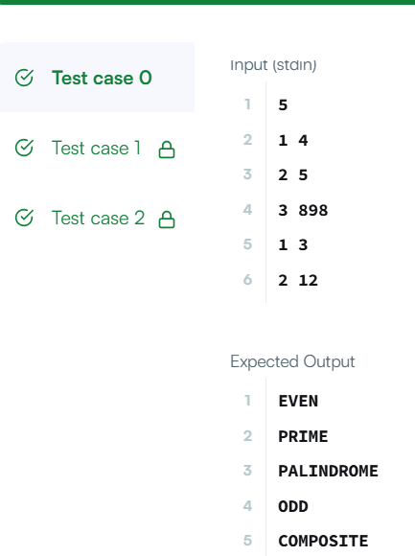

TASK 1.2:SALARY TRANSFORMATION SYSTEM

PROGRAM:
import java.util.*;
import java.util.stream.*;

public class Main {
public static void main(String[] args) {
Scanner sc = new Scanner(System.in);
int n = sc.nextInt();
List<Integer> salaries = new ArrayList<>();
for (int i = 0; i < n; i++) {
salaries.add(sc.nextInt());
}
salaries.stream()
.map(salary -> salary + (salary * 10 / 100))
.forEach(salary -> System.out.print(salary + " "));
}
}
OUTPUT:

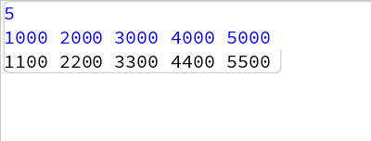

TASK 1.3:JAVA SORT

PROGRAM:
import java.util.*;
class Student{
private int id;
private String fname;
private double cgpa;
public Student(int id, String fname, double cgpa) {
super();
this.id = id;
this.fname = fname;
this.cgpa = cgpa;
}
public int getId() {
return id;
}
public String getFname() {
return fname;
}
public double getCgpa() {
return cgpa;
}
}
public class Solution
{
public static void main(String[] args){
Scanner in = new Scanner(System.in);
int testCases = Integer.parseInt(in.nextLine());

List<Student> studentList = new ArrayList<Student>();
while(testCases>0){
int id = in.nextInt();
String fname = in.next();
double cgpa = in.nextDouble();
Student st = new Student(id, fname, cgpa);
studentList.add(st);
testCases--;
}
// --- INSERTED SORTING LOGIC ---
Collections.sort(studentList, new Comparator<Student>() {
@Override
public int compare(Student s1, Student s2) {
// Compare by CGPA (Descending)
if (Double.compare(s2.getCgpa(), s1.getCgpa()) != 0) {
return Double.compare(s2.getCgpa(), s1.getCgpa());
}
// If CGPA is same, compare by First Name (Ascending)
else if (!s1.getFname().equals(s2.getFname())) {
return s1.getFname().compareTo(s2.getFname());
}
// If CGPA and First Name are same, compare by ID (Ascending)
else {
return Integer.compare(s1.getId(), s2.getId());
}
}
});
// --- END OF INSERTED LOGIC ---
for(Student st: studentList){
System.out.println(st.getFname());
}
}
}

OUTPUT:
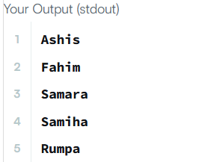

TASK 1.4: Sort Array By Parity

PROGRAM:
class Solution {
public int[] sortArrayByParity(int[] nums) {
int i = 0; // Pointer for the next even element's position
for (int j = 0; j < nums.length; j++) {
// If we find an even number, swap it with the element at index i
if (nums[j] % 2 == 0) {
int temp = nums[i];
nums[i] = nums[j];
nums[j] = temp;

i++; // Move the even pointer forward
}
}
return nums;
}
}

OUTPUT:
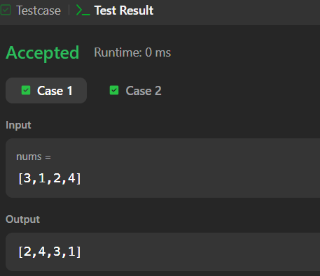

TASK 1.5: SORTING COMPARATOR

PROGRAM:
import java.util.*;
class Player {
String name;
int score;
Player(String name, int score) {
this.name = name;
this.score = score;
}
}
class Checker implements Comparator<Player> {
@Override
public int compare(Player a, Player b) {
// If scores are the same, sort alphabetically by name
if (a.score == b.score) {
return a.name.compareTo(b.name);
}
// Otherwise, sort by score descending
return b.score - a.score;
}
}
public class Solution {
public static void main(String[] args) {
Scanner scan = new Scanner(System.in);
int n = scan.nextInt();
Player[] player = new Player[n];
Checker checker = new Checker();
for(int i = 0; i < n; i++){
player[i] = new Player(scan.next(), scan.nextInt());
}
scan.close();

Arrays.sort(player, checker);
for(int i = 0; i < player.length; i++){
System.out.printf("%s %s\n", player[i].name, player[i].score);
}
}
}

OUTPUT:
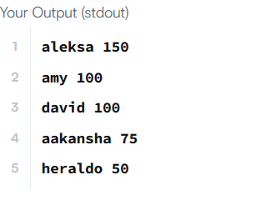

TASK 1.6: JAVA COMPARATOR

PROGRAM:
import java.util.*;
class Checker implements Comparator<Player> {
@Override
public int compare(Player a, Player b) {
// If the scores are identical, sort alphabetically by name (ascending)
if (a.score == b.score) {
return a.name.compareTo(b.name);
}
// Otherwise, sort by score (descending)
return Integer.compare(b.score, a.score);
}
}
class Player{
String name;
int score;
Player(String name, int score){
this.name = name;
this.score = score;
}
}
class Solution {
public static void main(String[] args) {
Scanner scan = new Scanner(System.in);
int n = scan.nextInt();
Player[] player = new Player[n];
Checker checker = new Checker();
for(int i = 0; i < n; i++){
player[i] = new Player(scan.next(), scan.nextInt());
}
scan.close();

Arrays.sort(player, checker);
for(int i = 0; i < player.length; i++){
System.out.printf("%s %s\n", player[i].name, player[i].score);
}
}
}

OUTPUT:
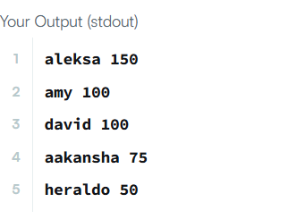

TASK 1.7:RICHEST CUSTOMER WELTH

PROGRAM:
class Solution {
public int maximumWealth(int[][] accounts) {
int maxWealth = 0;
// Loop through each customer's array of banks
for (int[] customer : accounts) {
int currentWealth = 0;
// Sum up the money in all banks for the current customer
for (int bank : customer) {
currentWealth += bank;
}
// Update maxWealth if the current customer is richer
maxWealth = Math.max(maxWealth, currentWealth);
}
return maxWealth;
}
}

OUTPUT:
